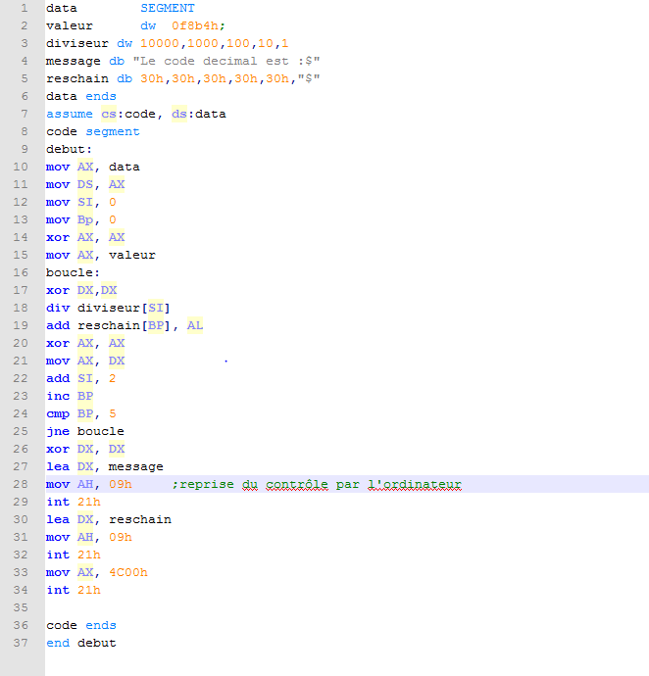
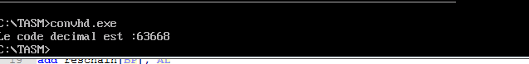
Exercice 1:

Exercice 2:

